33 Secrets to Start Pediatric Dental Assisting in Less Than 3 Months

It doesn’t take a college degree or some sort of medical school to be a pediatric dental assistant. You can receive pediatric dental assisting training in less than 3 months.
You will receive all of the certificates you need to work as a pediatric dental assistant in our 9 week program.
We have a 98% graduation rate and an 90% job placement rate which basically means that all our students begin working in a dental office very soon after finishing our program.

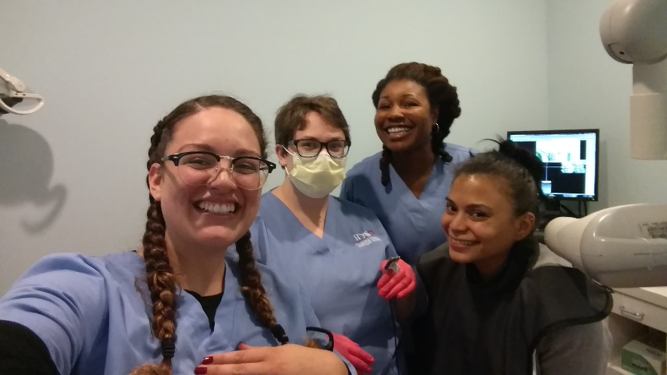

Bonus: Our classes are hands-on and fun. Our program is inexpensive, and we have affordable financial options.
Now that you know these secrets, YOU could be working as a Pediatric Dental Assistant in less than 3 months too!

